# AName: _______________ StudentID: ___________

## Activity 1 - Human Computer Interface (HCI) Analysis

## 

### Crown Casino: [[http://www.crownmelbourne.com.au](http://www.crownmelbourne.com.au/)]:

Here is a snapshot of Crown Casino's home page:

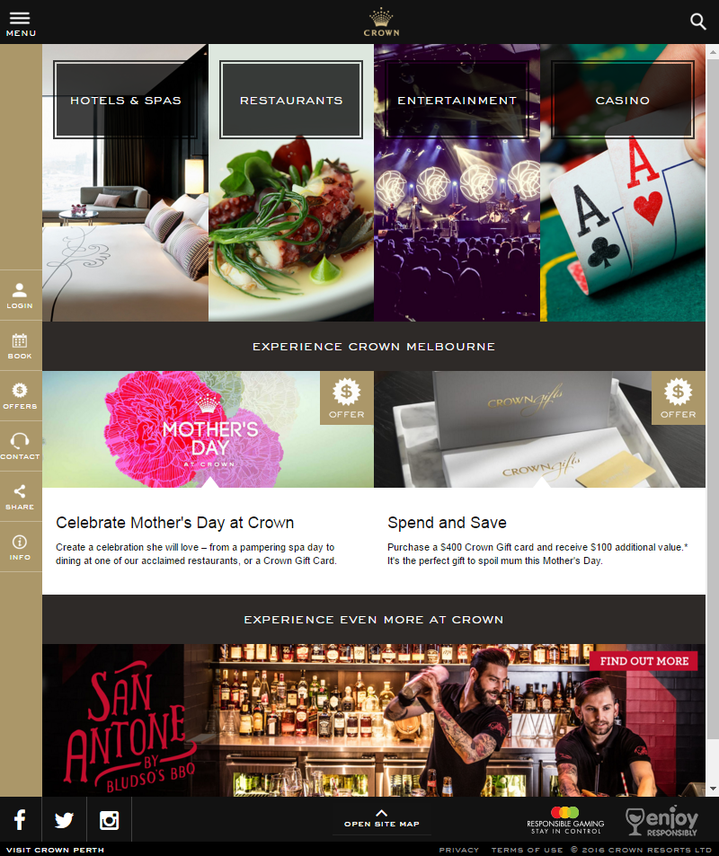

Discuss the following questions:

* What are the four business areas they are promoting on the home page? What types of audiences are they appealing to?  
  Ans:
  + Hotel & spa
  + Restaurant
  + Entertainment
  + Casino
  + They are appealing to people who want to go on high grade vacations and want to make some quick money
  + Aim at customer who travel alone or with a partner (not orientated toward family)
* Is the content on this home page (landing page) general in nature? Does it capture all audiences without alienating anyone?

Ans: The homepage is general in nature; it showed all the basics the hotel has to offer. It is designed to aim at a specific kind of customers (adult) and not family orientated.

* Are there any issues with contrast that will impact the visually impaired? Have any compromises been made in the name of stylish design? Test your color choices here: <https://contrast-ratio.com/>

Ans: Most area the page has high contrast ratio, however there are still some area that have low contrast ratio like the golden navigation bar on the left or the offer symbol. The site have some alternative way for people to see when they go into the general web page.

* Is the interface at all confusing? Does this website pose any problems for those with mobility or intellectual disabilities?

Ans: The website is a little confusing due to everything is pack tightly together (there is no free space), and the navigation bar is fill with a lot of options. So, it might pose some problem for those who have intellectual disabilities to easily navigate the site and hard for people with mobility disabilities since there are a lot of options.

Crown Casino charges rent from their commercial tenants. The success of Crown's business depends on the success of the tenants' businesses and so it makes sense for Crown to promote their tenants' businesses within their website. Below is a screenshot from the restaurant's and food market businesses category:

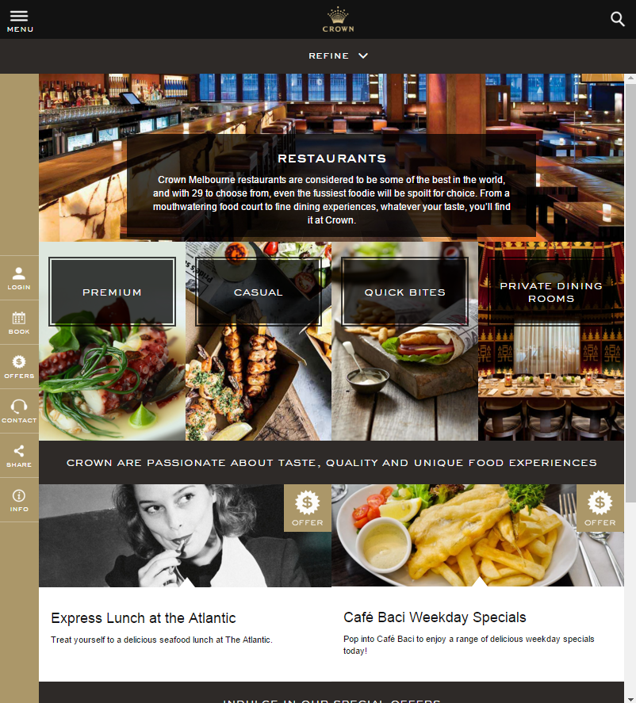

The content on this landing page is more specific: relating to places to eat, but it is still a landing page for 4 general types of audience. Name the 4 types of audience and is there any significance with the placement of each group of restaurants on the page?

Ans:

* Premium: For high-end customer, foodies or for people who have special occasions
* Casual: For customer who just want to dine, family
* Quick bites: For customer who want a light snack, for casino customer when on break, or for drinker
* Private dinning room: For people who have special occasions, private meeting.

The placement of types is sorted by the price of the dining experience (high to low) and an extra service which is private dinning room in the last category.

Think about what might attract each group and what would "scare" them away? In particular, how does it appeal to those looking for a lavish place to eat (eg Heston Blumenthal's restaurant?) without intimidating those who are on a budget and just want to visit KFC or McDonalds?

Ans: The site divided up the categories by how people want their dining experience to be and what are their budget. For those who want a fancy place to eat, they could click on the premium category to find out all the restaurants the hotel has to offer. Those restaurants might have dress code or social code that is not meant for casual, and the price and food (experience) will be high-end.

On the other hand, for those who want a more casual and fast food, they might not want to see others expensive restaurant and only want to find the place they want to eat quickly.